DEVIKA.B
Roll no:22

Experiment 5

Find Product with Lowest Price
Problem Statement

Aim: Write a Java program to define a class Product with data members pcode, pname, and
price. Find and display the product with the lowest price.

^{Source code}

import java.util.Scanner;

class Product {
String pcode;
String pname;
double price;

public Product(String pcode, String pname, double price) {
this.pcode = pcode;
this.pname = pname;
this.price = price;
}
}

public class SimpleProductManager {
public static void main(String[] args) {
Scanner scanner = new Scanner(System.in);

// Create an array to hold products
Product[] products = new Product[5]; // Limit to 5 products for simplicity

// Input product details
for (int i = 0; i < products.length; i++) {
System.out.println("Enter product code:");
String pcode = scanner.nextLine();

System.out.println("Enter product name:");
String pname = scanner.nextLine();

System.out.println("Enter product price:");
double price = scanner.nextDouble();
scanner.nextLine(); // Consume newline

products[i] = new Product(pcode, pname, price);
}

// Find the product with the lowest price
Product lowestPriceProduct = products[0];
for (Product product : products) {
if (product.price < lowestPriceProduct.price) {
lowestPriceProduct = product;
}
}

// Display the product with the lowest price
System.out.println("Product with the lowest price:");
System.out.println("Code: " + lowestPriceProduct.pcode);
System.out.println("Name: " + lowestPriceProduct.pname);
System.out.println("Price: $" + lowestPriceProduct.price);

scanner.close();
}
}

output
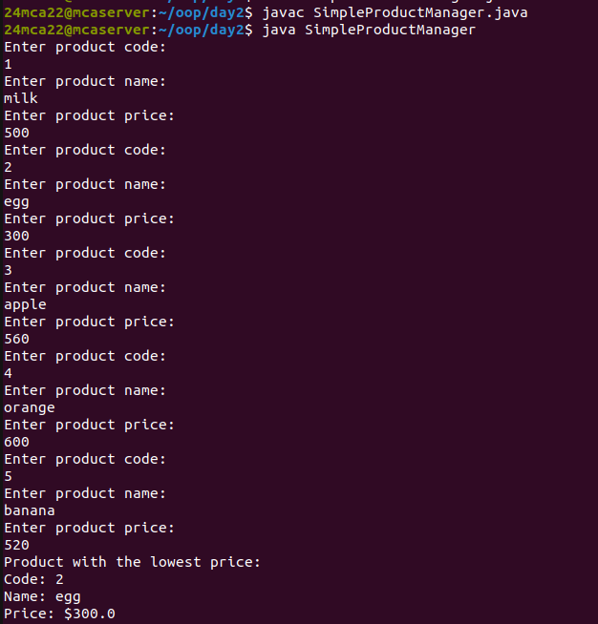

Experiment 6

Complex Number Operations
Problem Statement

Aim:Write a Java program to perform addition and multiplication of complex numbers, with
inputs provided by the user.

Source code

import java.util.Scanner;

class Complex {
double real, imaginary;

Complex(double r, double i) {
this.real = r;
this.imaginary = i;
}

Complex add(Complex other) {
return new Complex(this.real + other.real, this.imaginary + other.imaginary);
}

Complex multiply(Complex other) {
return new Complex(this.real * other.real - this.imaginary * other.imaginary,
this.real * other.imaginary + this.imaginary * other.real);
}

@Override
public String toString() {
return real + " + " + imaginary + "i";
}
}

public class ComplexNumbers {
public static void main(String[] args) {
Scanner scanner = new Scanner(System.in);

System.out.print("Enter real part of first complex number: ");
double r1 = scanner.nextDouble();
System.out.print("Enter imaginary part of first complex number: ");
double i1 = scanner.nextDouble();

System.out.print("Enter real part of second complex number: ");
double r2 = scanner.nextDouble();
System.out.print("Enter imaginary part of second complex number: ");
double i2 = scanner.nextDouble();

Complex c1 = new Complex(r1, i1);
Complex c2 = new Complex(r2, i2);

Complex sum = c1.add(c2);
Complex product = c1.multiply(c2);

System.out.println("Sum: " + sum);
System.out.println("Product: " + product);

scanner.close();
}
}

output

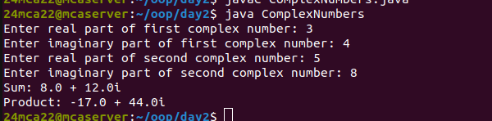

Experiment 7

Matrix Addition
Problem Statement

Aim:Write a Java program to perform matrix addition

Source code

import java.util.Scanner;

class Matrix {
private int rows, columns;
private int[][] data;

Matrix(int rows, int columns) {
this.rows = rows;
this.columns = columns;
data = new int[rows][columns];
}

void fillMatrix(Scanner scanner) {
System.out.println("Enter matrix elements:");
for (int i = 0; i < rows; i++) {
for (int j = 0; j < columns; j++) {
data[i][j] = scanner.nextInt();
}
}
}

Matrix add(Matrix other) {
Matrix result = new Matrix(rows, columns);
for (int i = 0; i < rows; i++) {
for (int j = 0; j < columns; j++) {
result.data[i][j] = this.data[i][j] + other.data[i][j];
}
}
return result;
}

void display() {
for (int[] row : data) {
for (int value : row) {
System.out.print(value + " ");
}
System.out.println();
}
}
}

public class MatrixAddition {
public static void main(String[] args) {
Scanner scanner = new Scanner(System.in);

System.out.print("Enter number of rows: ");
int rows = scanner.nextInt();
System.out.print("Enter number of columns: ");
int columns = scanner.nextInt();

Matrix matrix1 = new Matrix(rows, columns);
Matrix matrix2 = new Matrix(rows, columns);

matrix1.fillMatrix(scanner);
matrix2.fillMatrix(scanner);

Matrix sumMatrix = matrix1.add(matrix2);

System.out.println("Resultant Matrix after Addition:");
sumMatrix.display();

scanner.close();
}
}

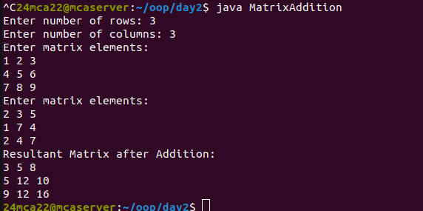
output

